

**Lab Manual- Create Own Helm Chart**

**Prepared for**:

**Date:** 18th Dec 2023

**Prepared by:**

Document Name: Lab Manual **Document Number** AZLabn916

**Contributor:**

Contents

[1. Objective 2](#_Toc157065691)

[2. Create Helm Chart From Scratch 25](#_Toc157065692)

# Objective

Helm charts are structured like this:

mychart/

Chart.yaml

values.yaml

charts/

templates/

...

The **templates/** directory is for template files. When Tiller evaluates a chart, it will send all of the files in the **templates/** directory through the template rendering engine. Tiller then collects the results of those templates and sends them on to Kubernetes.

The **values.yaml** file is also important to templates. This file contains the *default values* for a chart. These values may be overridden by users during helm install or helm upgrade.

The **Chart.yaml** file contains a description of the chart. You can access it from within a template. The charts/ directory *may* contain other charts (which we call *subcharts*). Later in this guide we will see how those work when it comes to template rendering.

**But another step you can take as you can convert that chart into standard Kubernetes YAML. Therefore, you can apply that to any cluster without having Helm present. It's a kind of optional**

<https://get.helm.sh/helm-canary-windows-amd64.zip>

or

<https://helm.sh/docs/intro/install/>

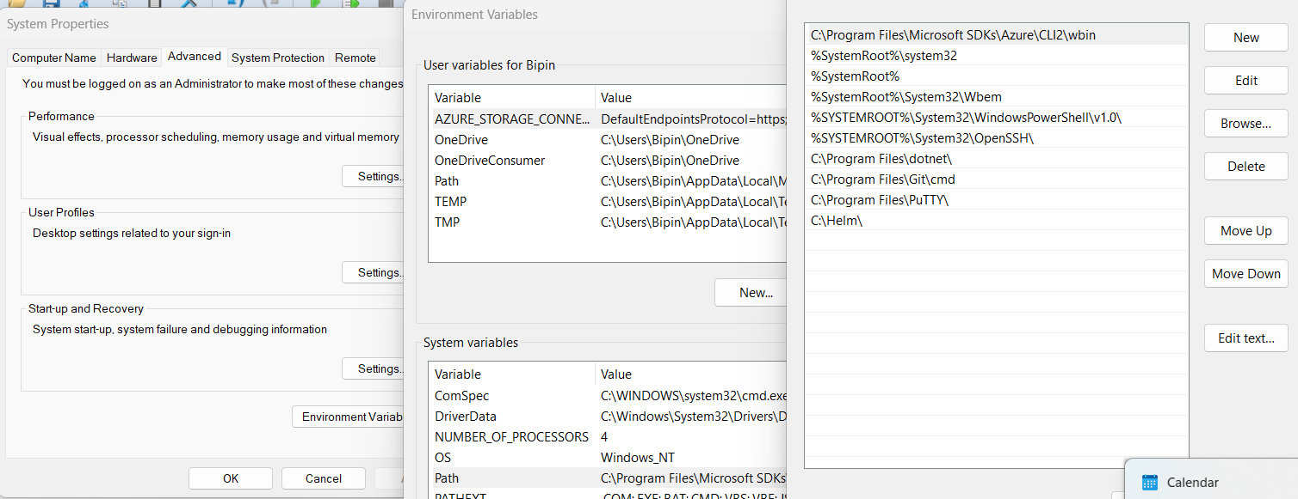

helm

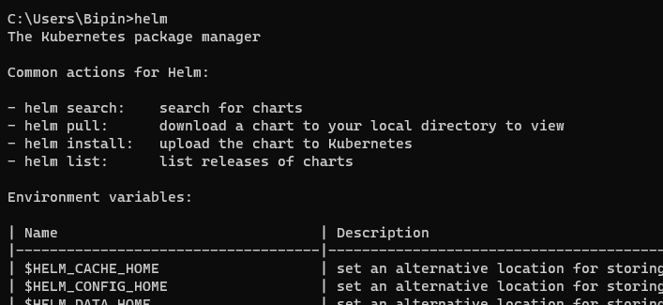

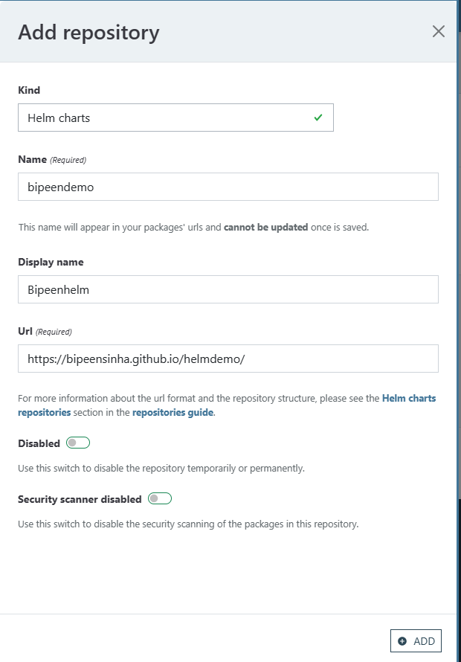

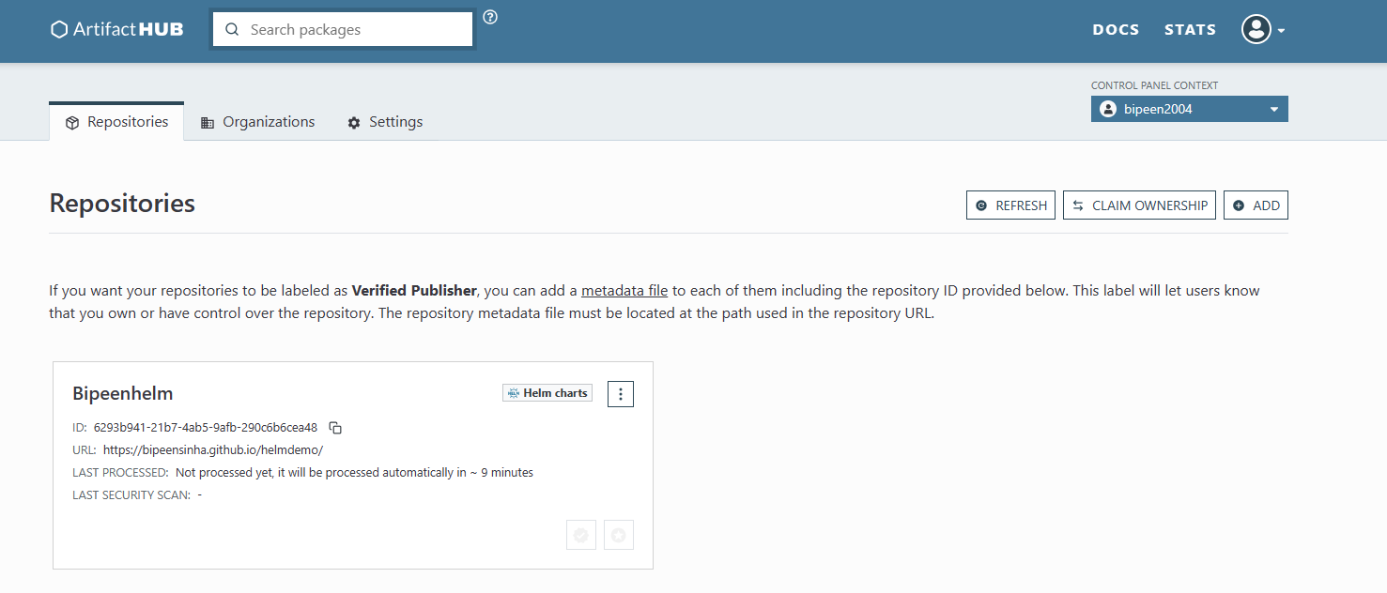

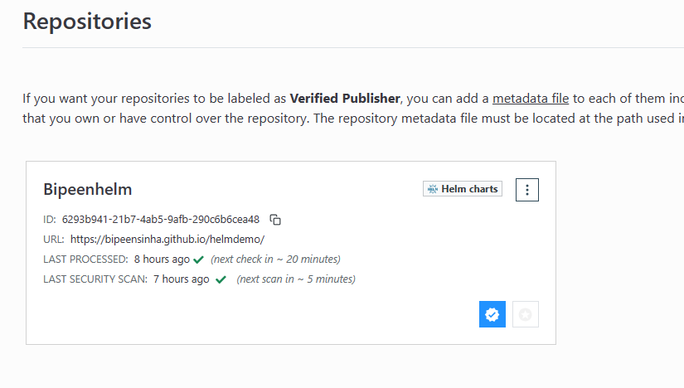

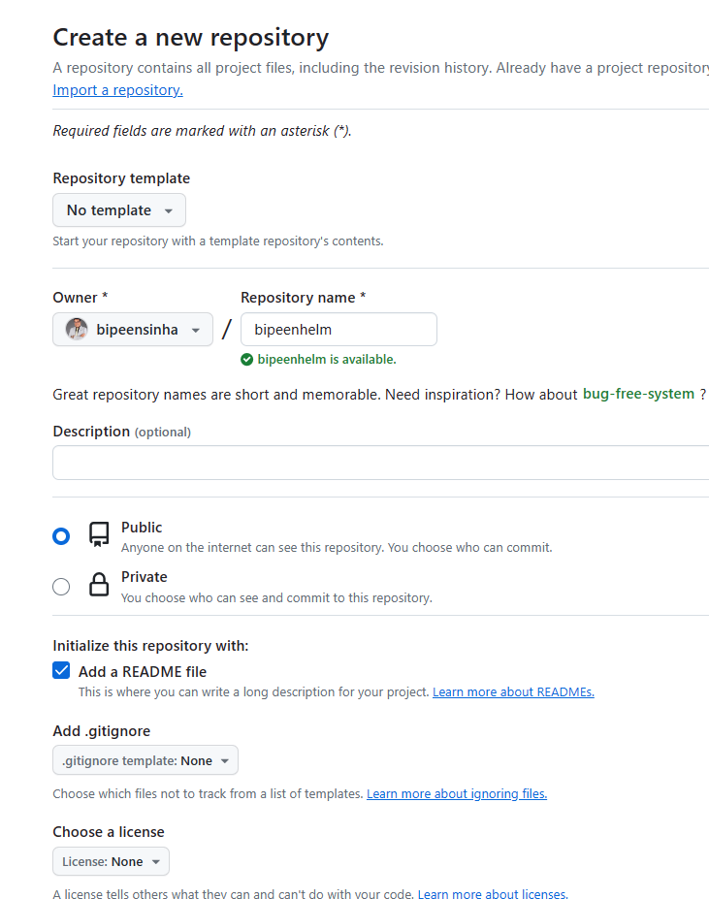

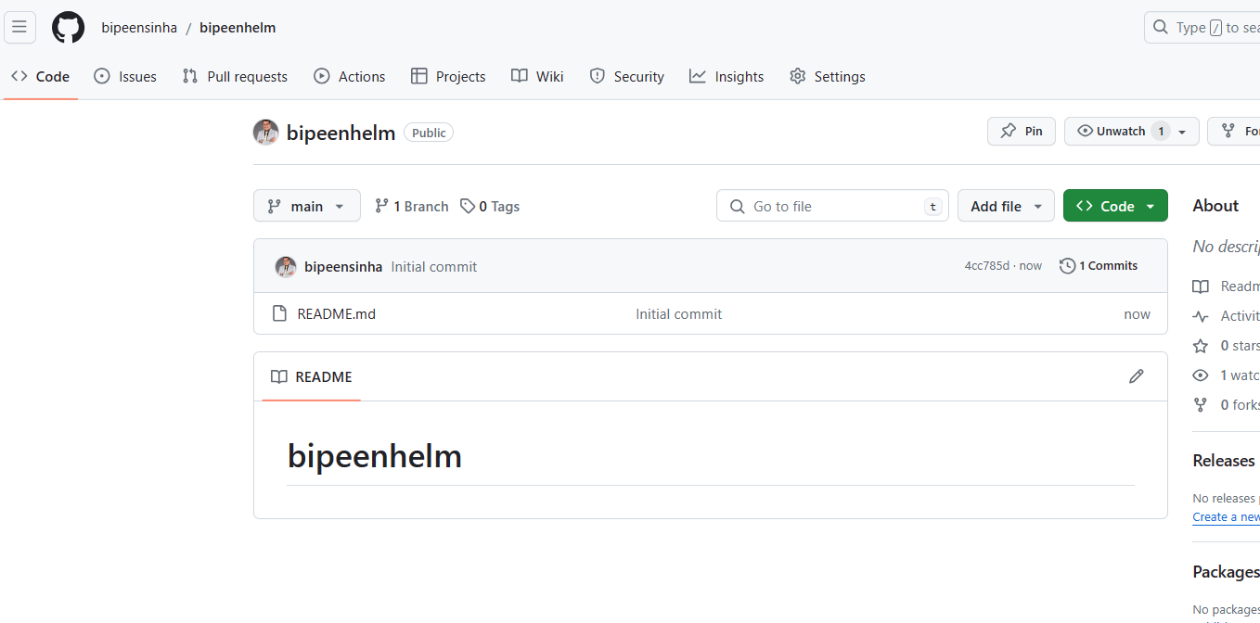

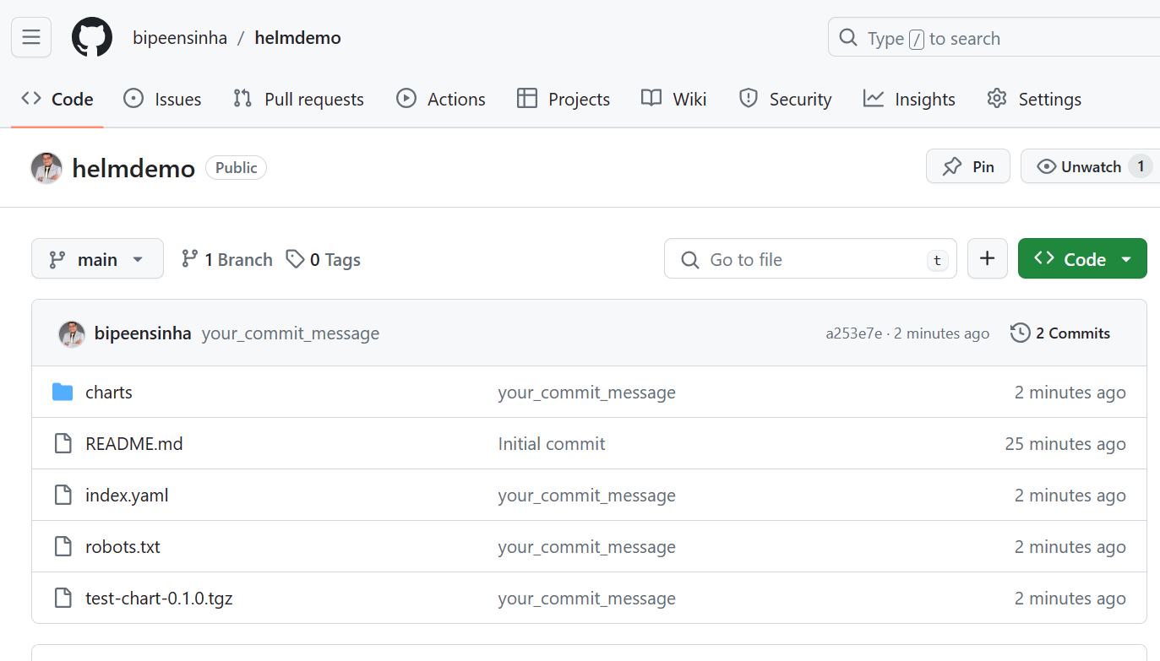

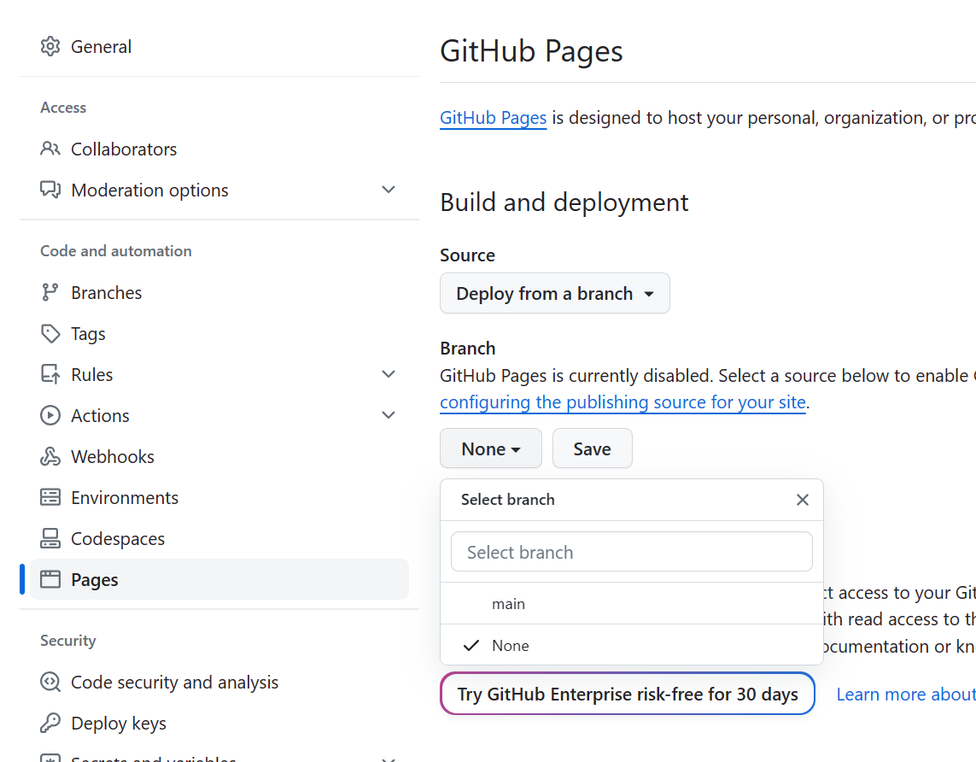

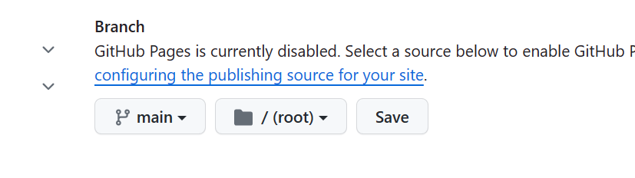

mkdir helmdemo-chart

cd helmdemo-chart

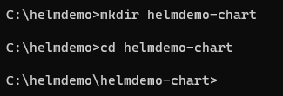

helm create bipeenhelm-chart



cd bipeenhelm-chart/templates

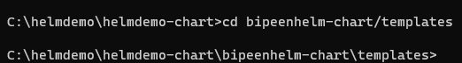

del /f \*



rmdir /s tests

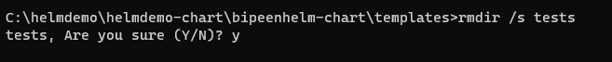

cd..

code .

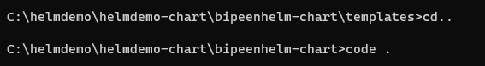

appVersion: "0.1.0 dev"

appVersion: "0.1.0 dev"

icon: https://www.google.com/images/branding/googlelogo/2x/googlelogo\_color\_272x92dp.png

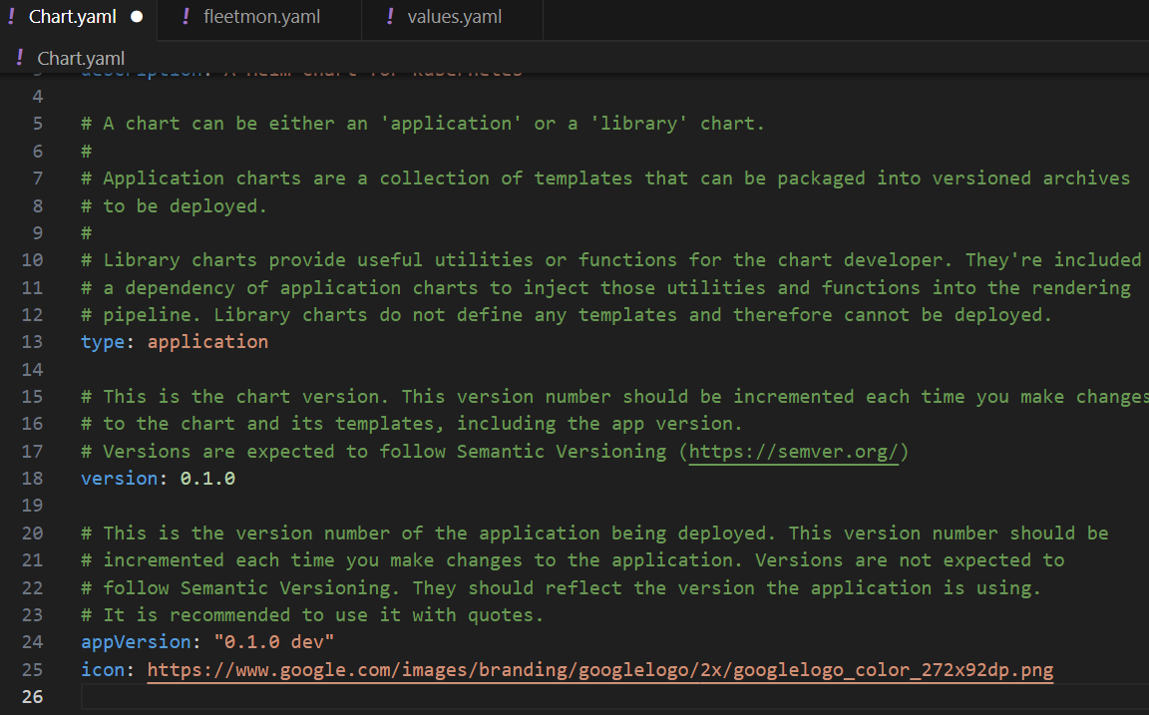

apiVersion: apps/v1

kind: Deployment

metadata:

  name: webapp

spec:

  selector:

    matchLabels:

      app: webapp

  replicas: 1

  template: # template for the pods

    metadata:

      labels:

        app: webapp

    spec:

      containers:

      - name: webapp

        # Note to deployer - add -dev at the end of here for development version

        image: {{ .Values.dockerrepo}}/k8s-fleetman-helm-demo

---

apiVersion: v1

kind: Service

metadata:

  name: fleetman-webapp

spec:

  selector:

    app: webapp

  ports:

    - name: http

      port: 80

      nodePort: 30080

  type: NodePort

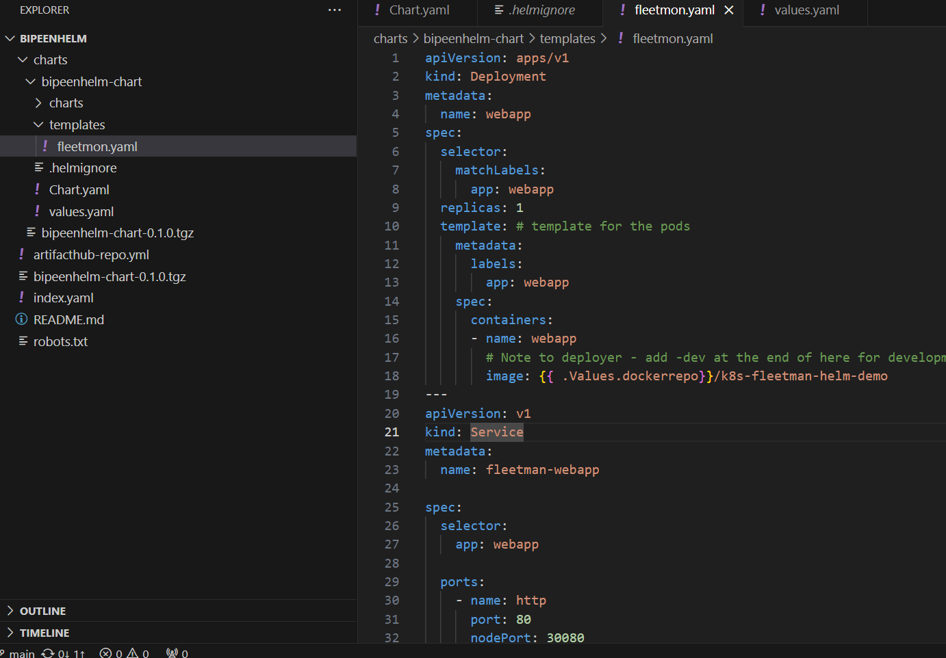

webapp:

  noofreplica: 4

dockerrepo: "richardchesterwood"

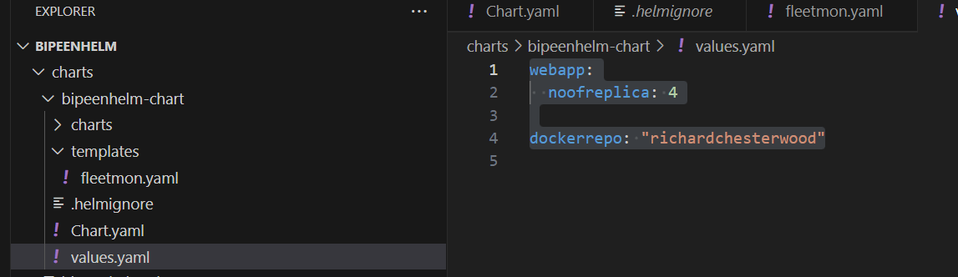

cd..

helm package bipeenhelm-chart



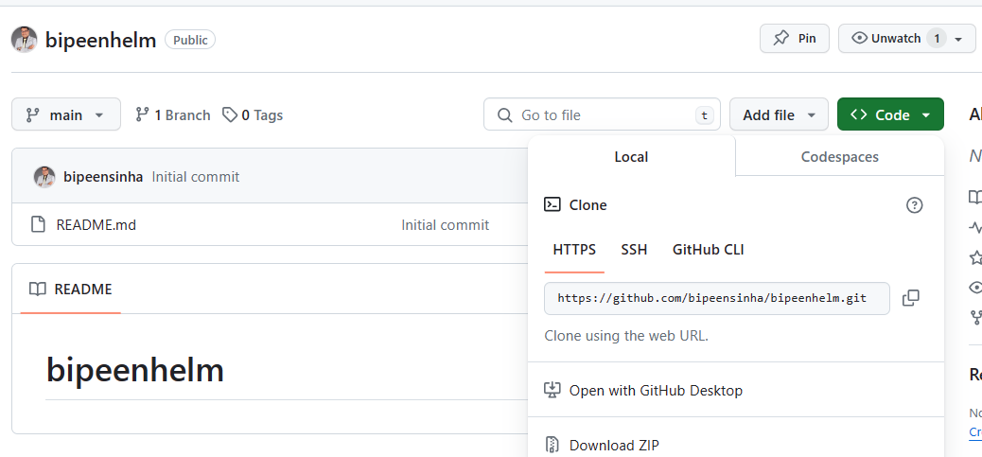

cd ..

git clone https://github.com/bipeensinha/bipeenhelm.git

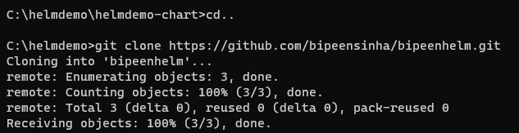

cd bipeenhelm

mkdir charts && cd charts

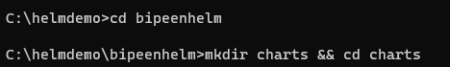

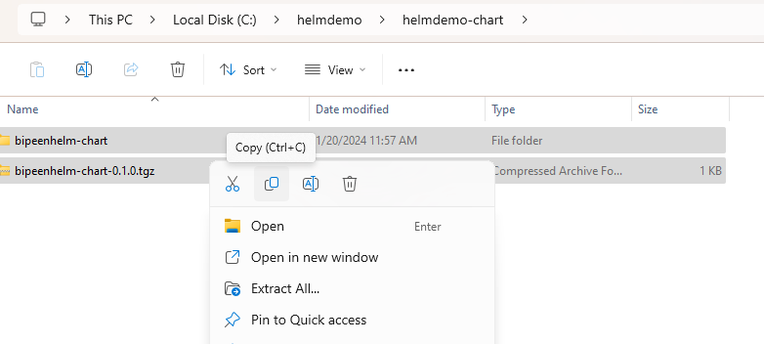

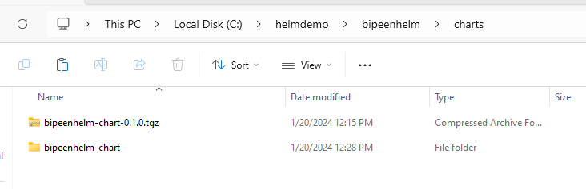

Dir

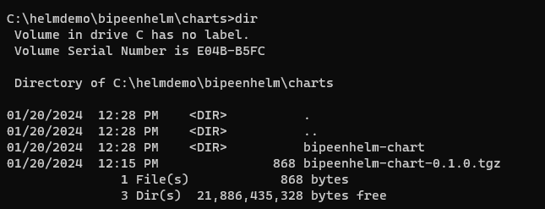

cd..



helm lint charts/bipeenhelm-chart

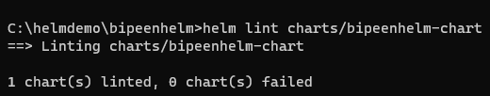

echo -e “User-Agent: \*\nDisallow: /” > robots.txt



Helm package charts/bipeenhelm-chart/



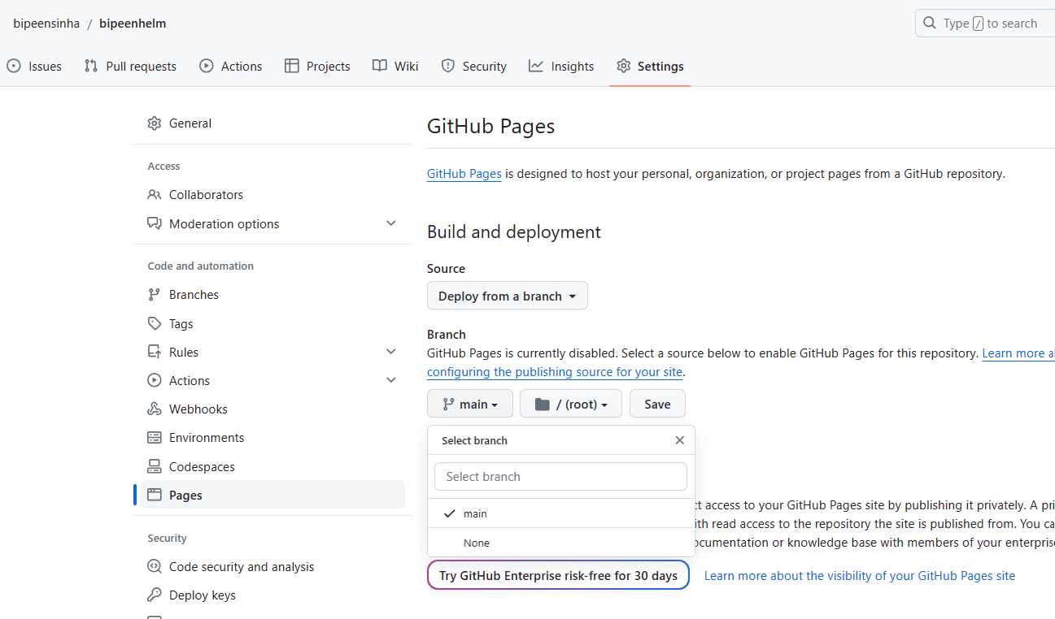

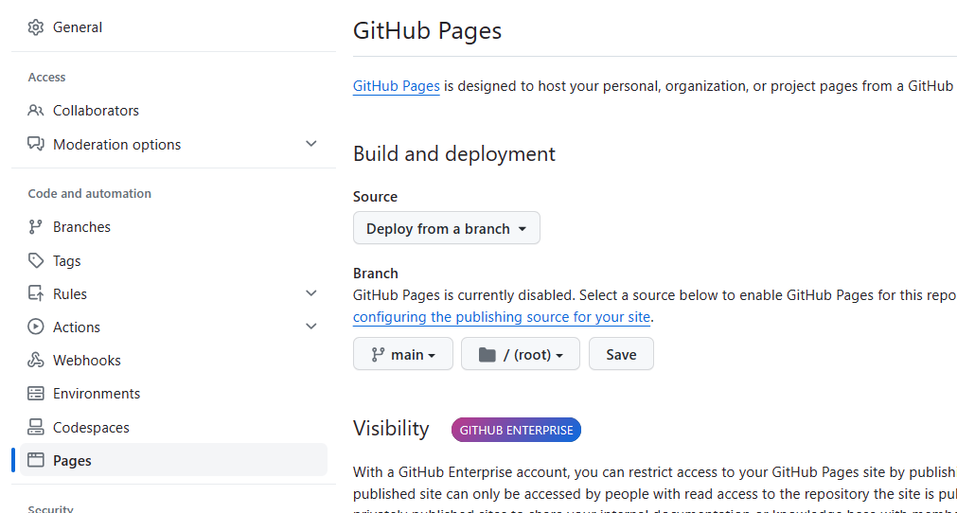

helm repo index --url https://bipeensinha.github.io/bipeenhelm/ .



Git add .

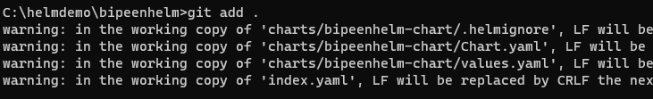

git commit -m "Bipeen Sinha First helm Chart"

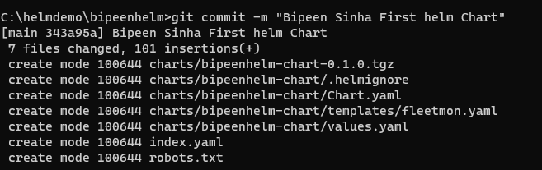

git push

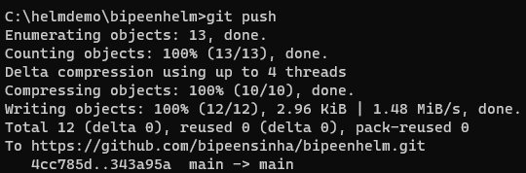

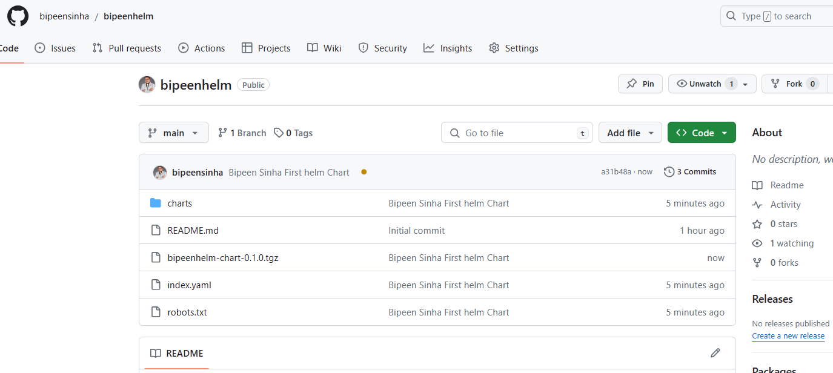

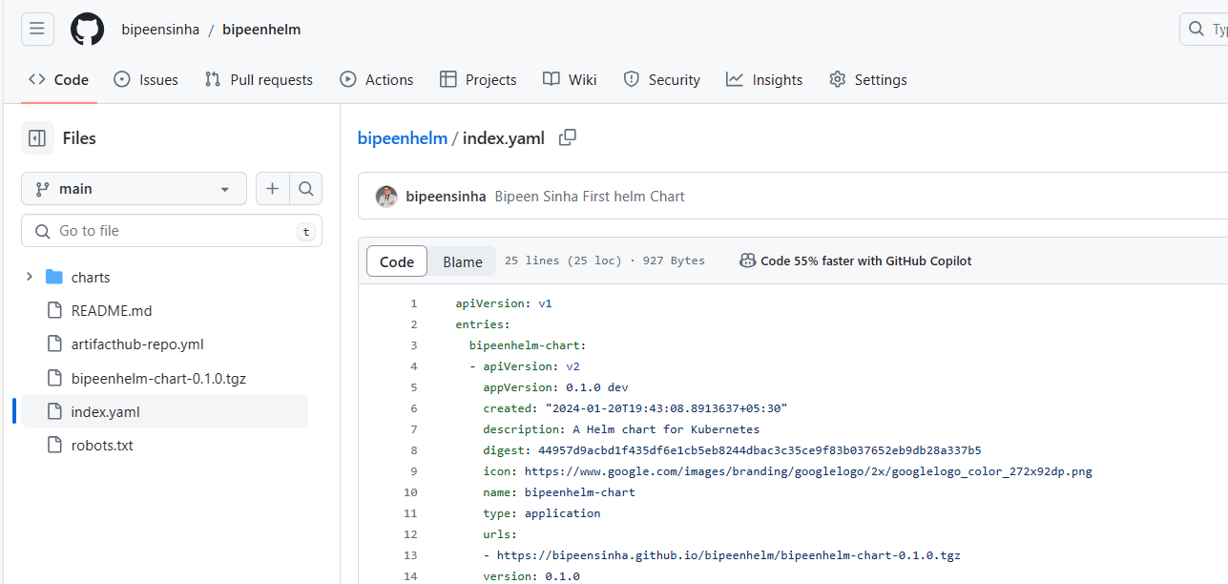

Now go to your [ArtifactHub account](https://artifacthub.io/" \t "_blank) and log in to it.

Now click on profile icon > control Panel> Add repository.

<https://artifacthub.io/>

click add

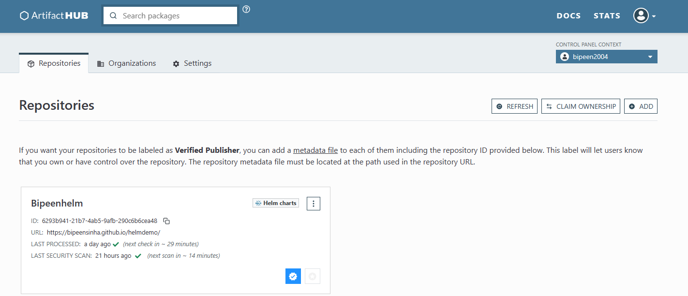

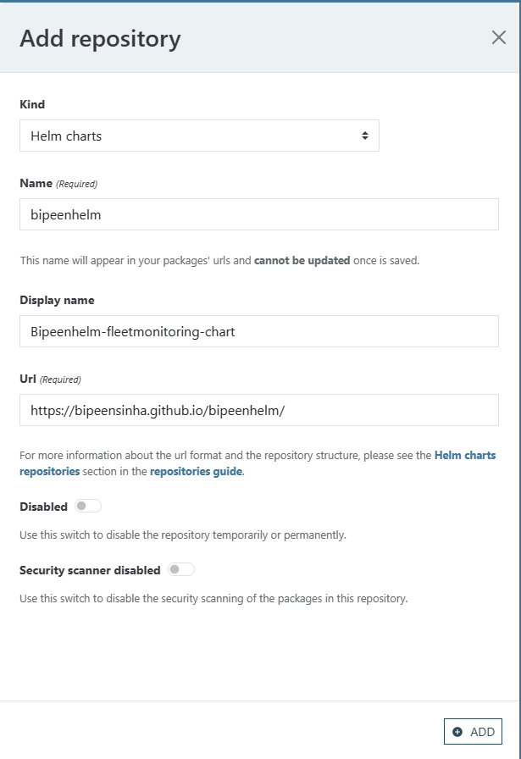

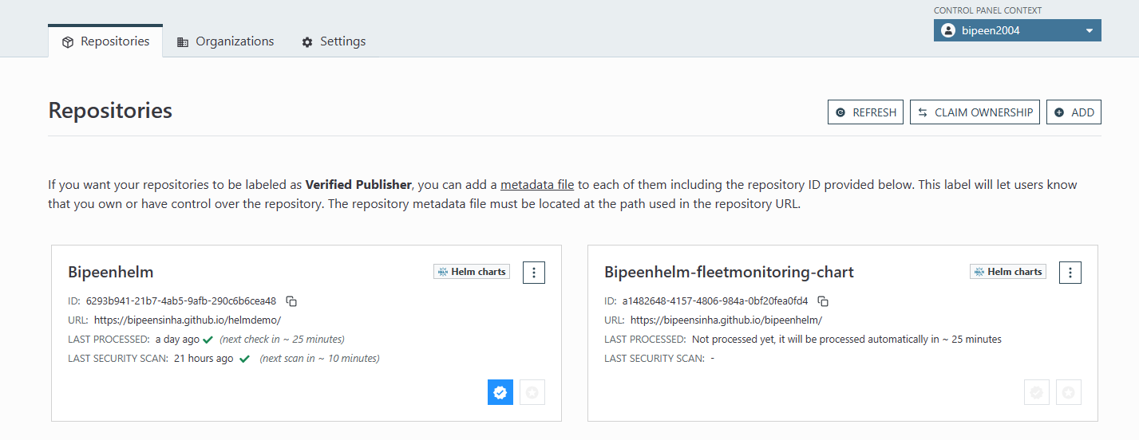

Ut will take 30 min to live

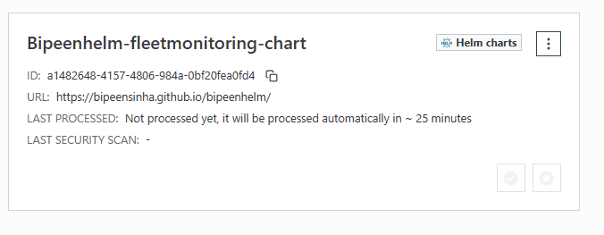

Create new file **artifacthub-repo.yml**

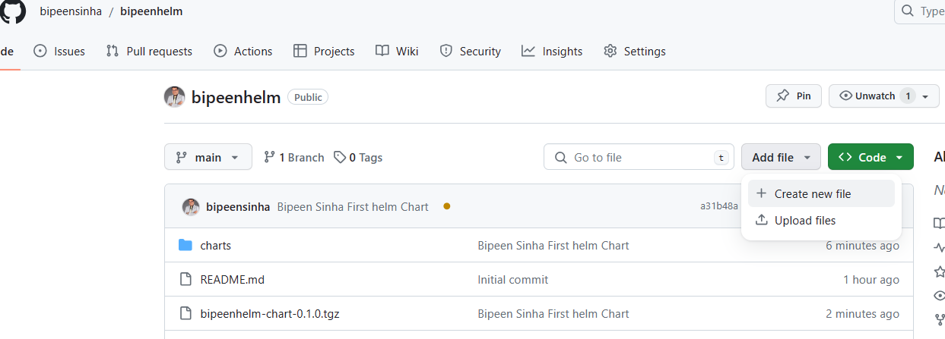

If you want your repositories to be labeled as **Verified Publisher**, you can add a [metadata file](https://github.com/artifacthub/hub/blob/master/docs/metadata/artifacthub-repo.yml) to each of them including the repository ID provided below. This label will let users know that you own or have control over the repository. The repository metadata file must be located at the path used in the repository URL.

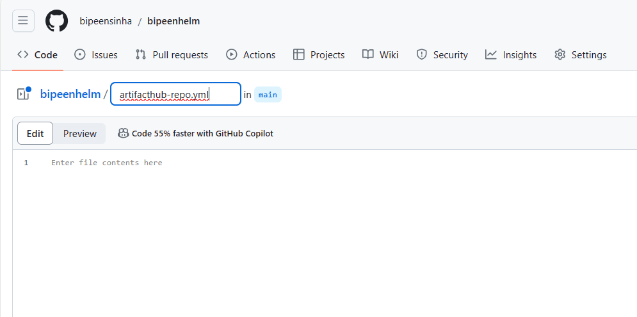

repositoryID: a1482648-4157-4806-984a-0bf20fea0fd4

owners:

- name: Bipeen Sinha

email: bipeen.sinha@hotmail.com

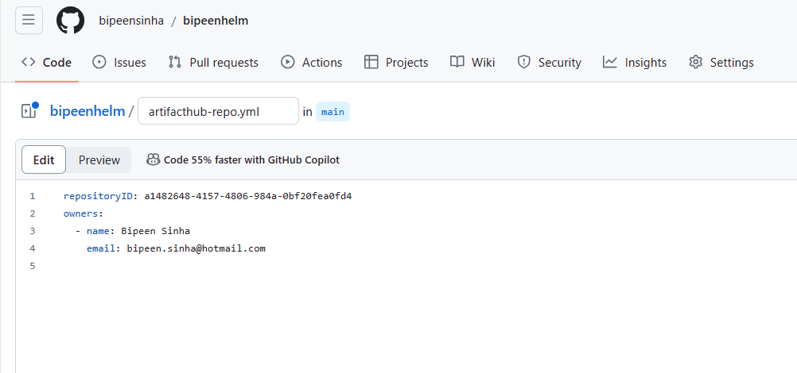

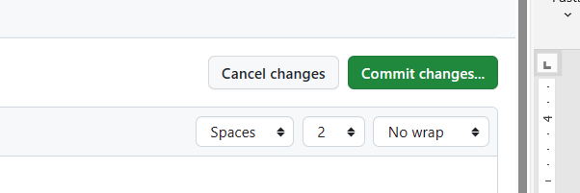

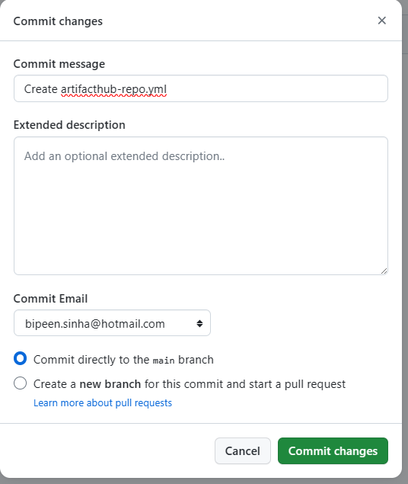

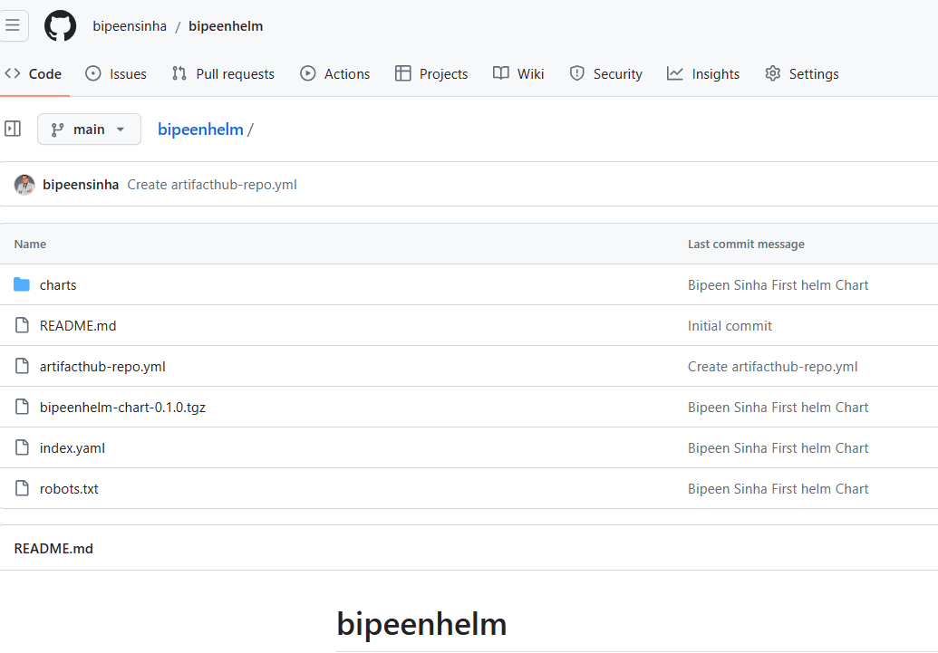

In 10-15 min you should see the pages in github is live

**Your site is live at**[**https://bipeensinha.github.io/bipeenhelm/**](https://bipeensinha.github.io/bipeenhelm/)

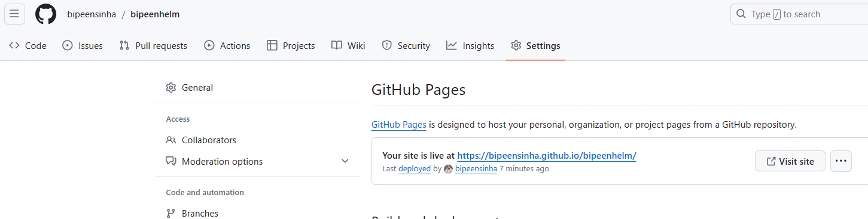

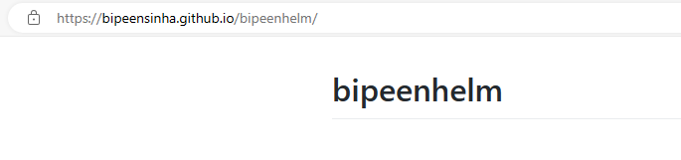

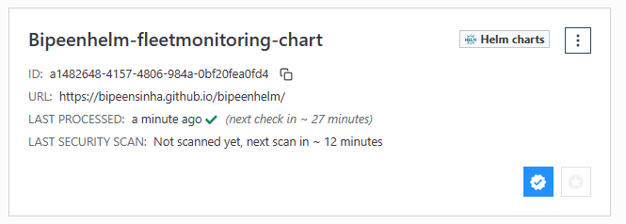

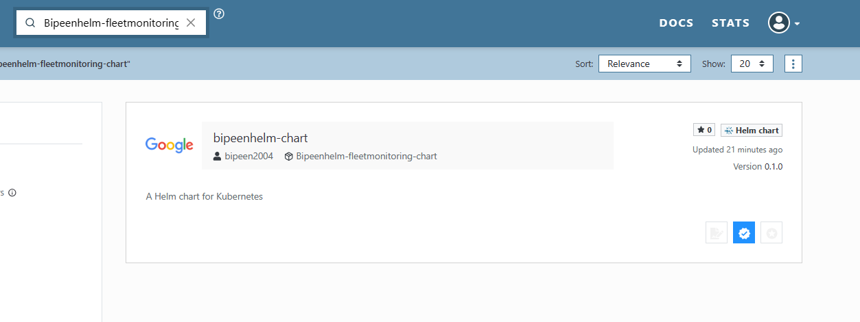

Cd..

cd..

helm repo add biprepo <https://bipeensinha.github.io/bipeenhelm/>

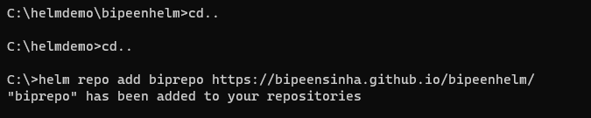

Helm repo list

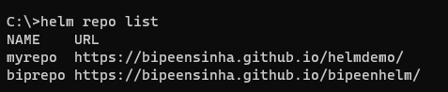

helm search repo

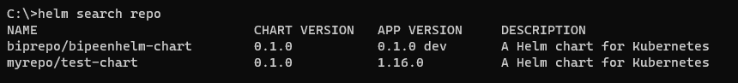

# Create Helm Chart From Scratch

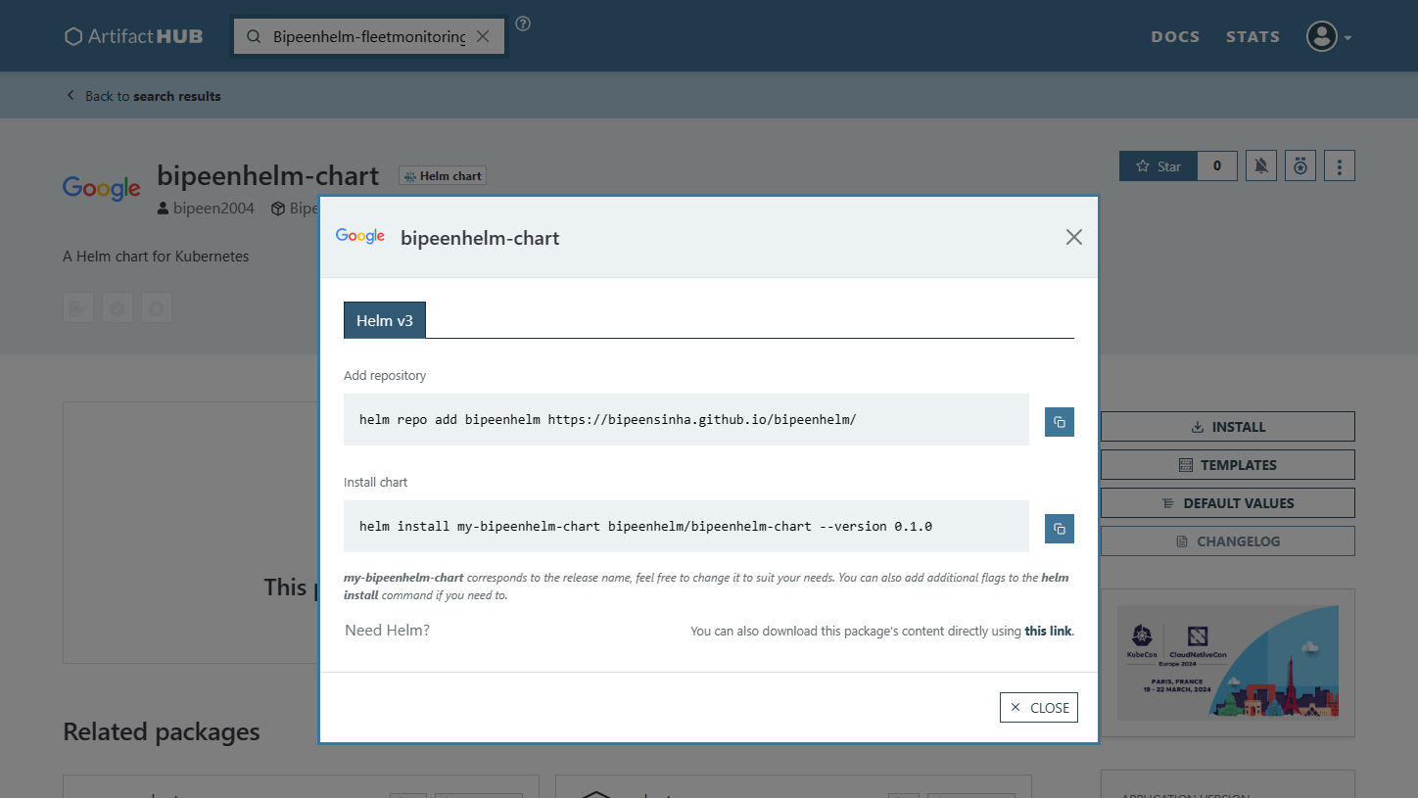

helm repo add bipeenhelm https://bipeensinha.github.io/bipeenhelm/



helm install my-bipeenhelm-chart bipeenhelm/bipeenhelm-chart --version 0.1.0

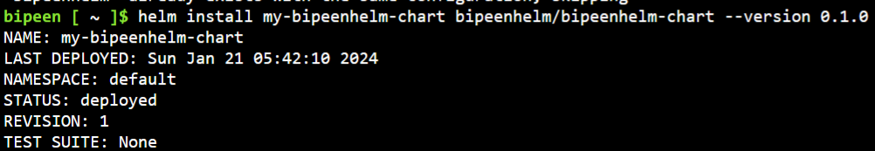

kubectl get service --watch

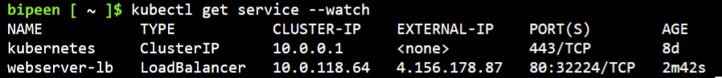

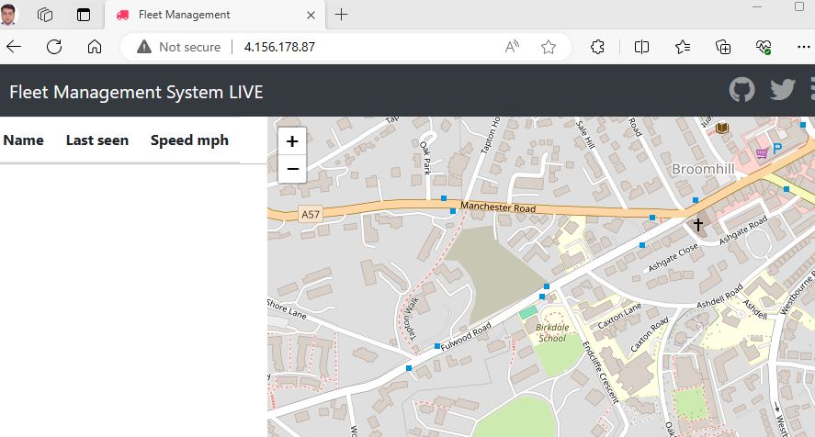

helm uninstall my-bipeenhelm-chart

